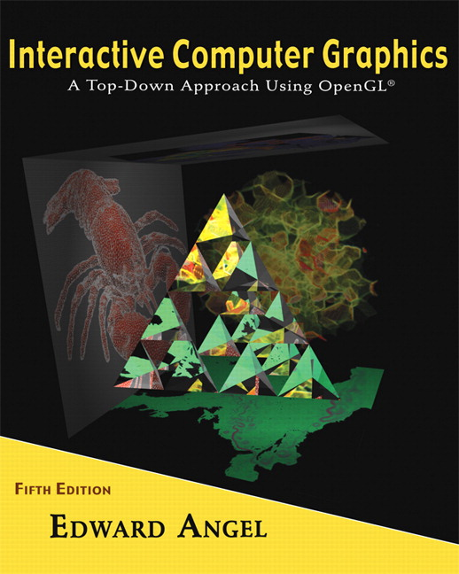 COSC 4370
Name: ____________________ TERMINAL NUMBER ____
Programming Assignment 4 Acceptance Testing:

After you downloaded your zipped project from BB and rebuilt it using the 200 PGH Visual Studio 2010, take screenshots of the output produced, and insert it in this file ……..
Lighting and Shading:
1. Place spot light at top inside right initial direction towards the center of the BUS.
SCREENSHOT Output of your program is:
……..

Texturing:
1. Texture your BUS by using either a texture similar to the actual BUS or any other BUS siding textures or bump mapping.
SCREENSHOT Output of your program is:
……..

Words on the BUS:
1. SCREENSHOT Output of your program is:
……..

Navigation:
1. Start at the DOOR looking toward the middle back BUS
SCREENSHOT Output of your program is:
……..
2. Second, Navigate starting at DOOR towards your spheres Driver Seat with the intent to collide with it.
Take some SCREENSHOTs Output of your program:
……..
3. Third, Navigate starting at DOOR towards your spheres Back of the Bus with the intent to collide with it.
Take some SCREENSHOTs Output of your program:
……..

Source Code:
1. Copy and Paste your .c (.cpp) file here:
…….

When done attach this file to “Testing Programming Assignment 4” BB assignment.

